**DATA COLLECTION**

A database is a separate application that stores a collection of data. Each database has one or more distinct APIs for creating, accessing, managing, searching and replicating the data it holds. So nowadays, we use relational database management systems (RDBMS) to store and manage huge volume of data. This is called relational database because all the data is stored into different tables and relations are established using primary keys or other keys known as foreign keys. MySQL is the most popular Open Source Relational SQL database management system MySQL is one of the best RDBMS being used for developing web-based software applications.

Users may use the included command line tools or use MySQL "front-ends", desktop software and web applications that create and manage MySQL databases, build database structures, back up data, inspect status, and work with data records

* 1. **Database**

The database that would be connected to the Web as well as Android app is created using MySQL since it is compatible with both. Following figure explains the structure of the database created.

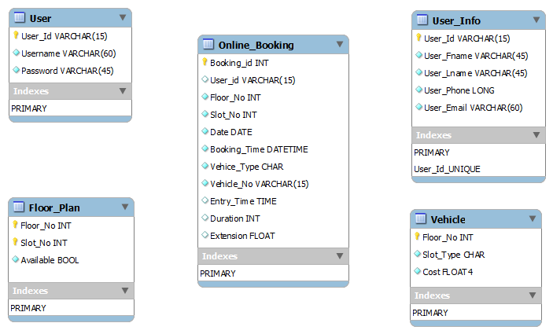

**Figure 5.1: Database Structure**

The database consists of five tables named User, Vehicle, Floor_Plan, Online_Booking, User_Info.

* The **User table** would consist of the information required by the user to access the facilities of both the apps.

The structure of user table is as follows:

`UserId` varchar(15) NOT NULL DEFAULT '' : Stores userid, length is 15 of type varchar.

`Username` varchar(60) NOT NULL: stores username, type is varchar and length is 60.

`Password` varchar(45) NOT NULL: stores password, type is varchar of length 45.

PRIMARY KEY: UserId

UNIQUE KEY: Username, UserId

* **Vehicle table** contains the fields to store the records related to the vehicle that would be parked in multistorey building.

The structure of user table is as follows:

`Floor_No` int (11) NOT NULL: stores the floor number of type int.

`Slot_Type` char (1) NOT NULL: stores the slot type.

`Cost` float NOT NULL: stores the cost of the slot.

PRIMARY KEY: Floor_No.

* The **Floor_Plan table** is for all the information related to the different floors of the building such as the floor number, number of slots and if any space is left on that floor or not.

The structure of user table is as follows:

`Floor_No` int(11) NOT NULL: stores the floor number of type int.

`Slot_No` int(11) NOT NULL: stores the slot number of type int.

‘Available` int(11) NOT NULL: stores the information whether slot is available or not.

PRIMARY KEY: Combination of Floor_No and Slot_No

* The table named **Online_Booking** stores the relevant records of all the users who have parked their vehicles in that building on that particular day.

The structure of user table is as follows:

`Booking_Id` int(11) NOT NULL AUTO_INCREMENT: stores the booking id. It auto increments to next value.

`UserId` varchar (30) NOT NULL: stores userid of type varchar of length 30.

`Floor_No` int (11) NOT NULL: stores the floor number of selected slot.

`Slot_No` int (11) NOT NULL: stores the selected slot number.

`Date` date NOT NULL: stores the date of booking.

`Booking_Time` time NOT NULL: stores the time of booking.

`Vehicle_Type` char (1) NOT NULL: stores the vehicle type.

`Vehicle_Number` varchar (15) NOT NULL: stores the vehicle number of parked car.

`Entry_Time` time NOT NULL: stores the entry time of the car.

`Duration` int (11) DEFAULT NULL: stores the time duration for which the car would be parked.

`Extension` float DEFAULT '0': whether extension of time duration is required or taken.

PRIMARY KEY: Booking_Id.

* The **User_Info table** is used for storing the information of all the users using the apps, either web app or the Android one.

The structure of user table is as follows:

`sn` int(11) NOT NULL AUTO_INCREMENT: serial number. It auto increments to next value in the sequence.

`UserId` varchar(15) NOT NULL: stores the user id.

`Fname` varchar(45) NOT NULL: stores the user’s first name.

`Lname` varchar(45) NOT NULL:stores the user’s last name.

`Phone` varchar(15) NOT NULL: stores the user’s phone number.

`Email` varchar(60) NOT NULL: stores the emailed of the user.

PRIMARY KEY: sn

UNIQUE KEY: sn